Project Synopsis

The overall OSINT project is divided into 4 modules. They are

1. Personal Details
2. Close Connections
3. Target Profiling
4. Uncanny Resources
5. Personal Details -

Details such as

1. Gender
2. D.O.B
3. Employment Status
4. Marital Status
5. Family details
6. Educational background
7. Close Friends

All these details can be easily accessed from Facebook through Web Scraping. Web Scraping is used because facebook recently closed their api.

Workflow:

The Input to the system is the target’s name and his photo. There are many profiles with the same username, so to overcome this we are using selenium for web scraping facebook. The users with the same username are being identified and later on face recognition is implemented on each of the user’s profile. The ID having the maximum matches is the target’s user-id.

THE TARGET’S FACEBOOK ACCOUNT IS BEING IDENTIFIED.

2) Close Connections - The close connections are identified by getting all the followers of instagram and twitter through selenium and their respective api’s. The intersection of all these records can be used to identify the close friends.

Future scope - This can also be implemented with the people tagged, number of replies and through other resources

3) Target Profiling - We are using Twitter api to get the tweets of the user and performing sentiment analysis on the same, this will give the overall profile of the user along with the most number of words used in his tweets, and can be useful in an investigation.

4) Uncanny Resources - This module is to be used only when the user is found with some abnormal activity. This module is used for Social Engineering and Web Page Hijacking through Malwares. When a user is spotted with an abnormal activity then at that time the safety of people is more important than the privacy of the user and at that time we can perform this attack!!!

Technology Stack -

PYTHON 3.6

SELENIUM

BEAUTIFUL SOUP & REQUESTS

DLIB AND FACE_RECOGNITION

OPENCV

HTML, CSS & FLASK

TWITTER API

AZURE, WATSON API

BROWSER EXPLOITATION FRAMEWORK XSS

METASPLOIT

**---------------------------------------------------------------------------------------------------------**

Test Case -

**Input:** Siddhart Mahajan Pune

**Picture:**

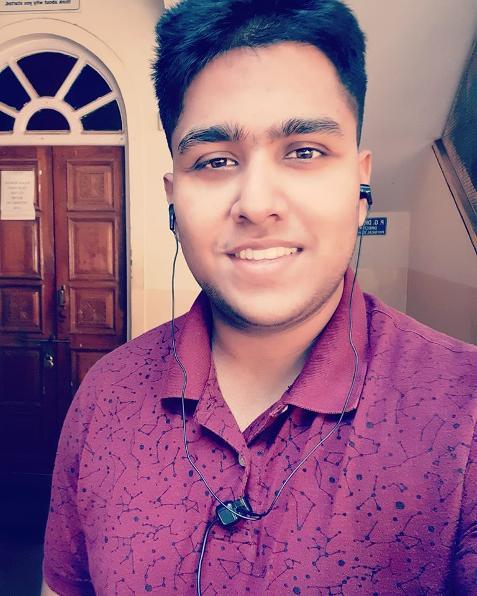

**Output:**

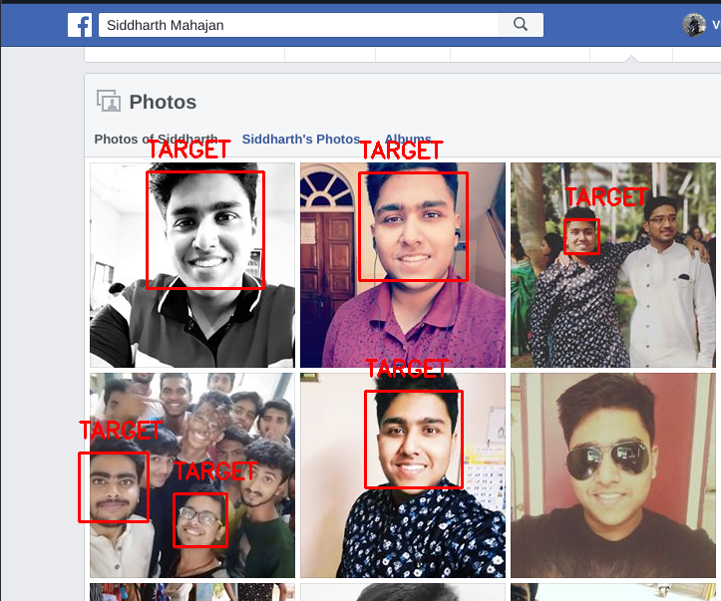

Opening Browser...

Logging in vishwa20@outlook.com automatically...

Scrolling to bottom...

Friends/friends.html) Downloaded

*****USER BIO*****

Username: siddharth.mahajan.79

NAME : Siddharth Mahajan

PHOTO_URL :<https://scontent.fhyd12-1.fna.fbcdn.net/v/t1.0-1/cp0/e15/q65/c0.0.74.74a/p74x74/50047032_2267573016832285_427191015061848064_o.jpg?_nc_cat=101&efg=eyJpIjoiYiJ9&_nc_oc=AQk2BRau_Ft6atFsDyYdmLxSn9Vc1C7xFlCFxsWR5_wdoAZjrYDEORMwp_BmPiwKf9g&_nc_ht=scontent.fhyd12-1.fna&oh=e6fd3417c81c959460f798e4af288ff2&oe=5E4A186E>

TAGLINE : The BIG Bang Theory FAN 🔥🔥 , CAMILA CABELLO FAN 🔥🔥, MALUMA FAN🔥🔥!!

..LIFE IS A GARDEN, DIG IT!!

REL : Single

DETAILS :

CURRENT CITY : Jammu

MOVED IN 2010 : Mumbai, Maharashtra

HOME TOWN : Jammu

FACEBOOK : /siddharth.mahajan.79

BIRTHDAY : 24 March 1999

GENDER : Male

WORK :

LINK : mbasic.facebook.com

ORG : MIT World Peace University

LINES : ['Studying', '22 July 2017 - Present', 'Pune, Maharashtra']

LINK : mbasic.facebook.com

ORG : jodhamal public school,jammu

LINES : ['Student', '12 April 2005 - Present']

EDUCATION :

LINK : mbasic.facebook.com

ORG : jodhamal public school

LINES : ['High School']

LINK : mbasic.facebook.com

ORG : S.P. Smart Hr. Sec. School ; Kachi Chawni Jammu

LINES : ['High School', 'March 2015 - 2018']

FAMILY :

NAME : Tanvi Gupta Sethi

REL : Cousin

ALIAS : mbasic.facebook.com/tanvi.gupta.7927

LIFE_EVENTS :

YEAR : 2018

TITLE : Left S.P. Smart Hr. Sec. School ; Kachi Chawni Jammu

LINK : mbasic.facebook.com/siddharth.mahajan.79/timeline/story?ut=32&wstart=-2051193600&wend=2147483647&hash=1660285380894388&pagefilter=3

YEAR : 2017

TITLE : Started new job at MIT World Peace University

LINK : mbasic.facebook.com/siddharth.mahajan.79/timeline/story?ut=32&wstart=-2051193600&wend=2147483647&hash=2201172400139014&pagefilter=3&ustart=1

YEAR : 2015

TITLE : Started studying at S.P. Smart Hr. Sec. School ; Kachi Chawni Jammu

LINK : mbasic.facebook.com/siddharth.mahajan.79/timeline/story?ut=32&wstart=-2051193600&wend=2147483647&hash=1660285380894388&pagefilter=3&ustart=1

YEAR : 2010

TITLE : Moved to Mumbai, Maharashtra

LINK : mbasic.facebook.com/100007388262849/posts/1429542737301988/

YEAR : 2008

TITLE : Travelled to Washington D.C.

LINK : mbasic.facebook.com/100007388262849/posts/1429542593968669/

YEAR : 2007

TITLE : First flight

LINK : mbasic.facebook.com/100007388262849/posts/1511561509100110/

YEAR : 2005

TITLE : Started new job at jodhamal public school,jammu

LINK : mbasic.facebook.com/siddharth.mahajan.79/timeline/story?ut=32&wstart=-2051193600&wend=2147483647&hash=1429538323969096&pagefilter=3&ustart=1

*****FRIEND LIST*****

Yashika Gupta <https://www.facebook.com/yashika.gupta.718>

Shreya Gangula <https://www.facebook.com/uugghh.1234>

Utkarsh Mishra <https://www.facebook.com/utkarsh.mishra.vw>

Sanket Dumbare <https://www.facebook.com/Sanket.Dumbare10>

Saket Padmanabhi <https://www.facebook.com/saket.padmanabhi>

Yadnesh Talokar <https://www.facebook.com/yadnesh.talokar.5>

Viraj Pandit <https://www.facebook.com/viraj.pandit.566>

Vedant Patil Choudhari <https://www.facebook.com/vedant.choudhari.9>

Vivek Ray <https://www.facebook.com/vivek.ray.92351>

Yogesh Khubchandani <https://www.facebook.com/profile.php?id=100009699842313>

Yash Kalaria <https://www.facebook.com/yash.kalaria>

Yash Damania <https://www.facebook.com/yash.damania.92>

Uday More <https://www.facebook.com/uday.more.965>

Omprakash Gadewar <https://www.facebook.com/omprakash.gadewar.9>

Sugandh Kumar <https://www.facebook.com/sugandh.kumar.395669>

Siddhi Bansore <https://www.facebook.com/profile.php?id=100009308523710>

Alok Bhawankar <https://www.facebook.com/alok.bhawankar>

Piyush Mishra <https://www.facebook.com/piyush.mishra.1999>

Yash Channe <https://www.facebook.com/yash.channe.5>

Omkar More <https://www.facebook.com/omkar.more.12139>